Welcome Guide

113 E Horseshoe AV
Gilbert, AZ 85296

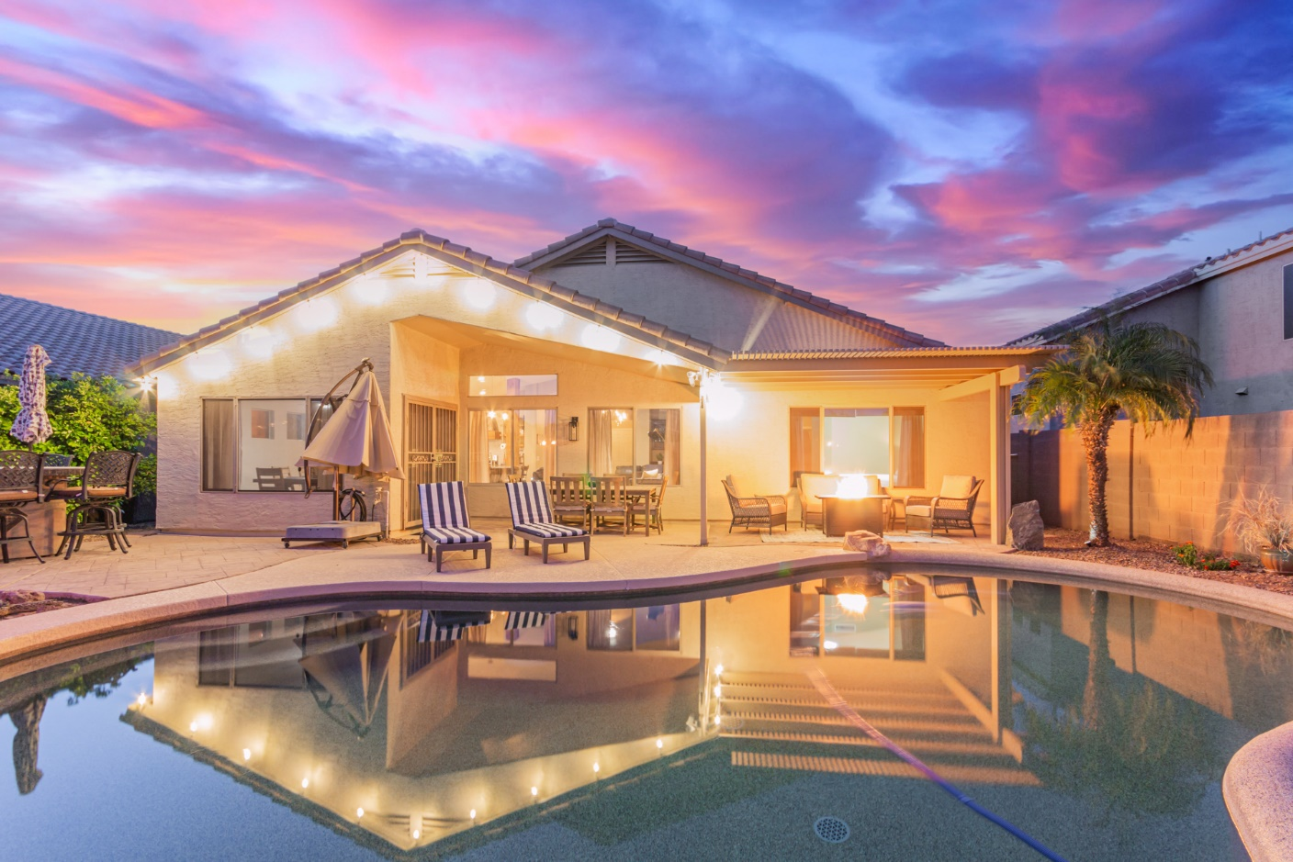

Wifi
Network name: Horseshoe 5G
Password: DarlingGilbert

Check In - 4:00pm
Welcome to your home away from home.
Parking
No street parking, please park in garage or driveway.

Pool Maintenance
Pool Service is every Thursday morning.

Pest Control
Monthly

Landscape Maintenance
Landscaping/Gardening service is monthly.

Trash Collection
Garbage and Recycle cans are picked up on Wednesday. Please place any trash in bins and put out on curb Tuesday evening, please bring bins in after pickup. Garbage cans located on the side of house.

Housekeeping
If you would like any additional housecleaning during your visit, Call Chris (520) 709-1470.

Security and Recording Devices
For security and safety purposes a ring doorbell at the front door and another camera installed on the back patio. All cameras will be recording and accessed as necessary. For privacy there are no cameras inside the property.

TV’s
All of the TVs are Smart Roku TVs so you'll be able to log-in and stream all of your favorites.

House & Community Rules

- Don’t touch pool equipment.

- N0 glassware in pool area, plastic cups available for outdoor use.

- Smoking is prohibited.

- Events, parties, or large gatherings are NOT allowed.

- Please be respectful of the neighbors and keep outdoor noise down between 10 pm - 8 am.

- No overnight Street Parking.

Check Out Checklist
We sincerely hope you enjoyed our space and felt at home during your stay. Please visit us again and have a safe journey home!

Check out time is 11:00 AM
- Take all trash out to the correct bins.
- Place all dirty dishes in the dishwasher and start it.
- Start a load of towels in the washer.
- Turn off all lights.
- Do NOT strip sheets or make any used beds, housekeeping will remove and wash all bedding.
- Make sure all exterior doors are locked and windows are closed.

